AI MATH TUTOR

TEAM ID: SWTID-2026-7601
TEAM LEADER: THANGA ANUSUYA S
TEAM MEMBER: SAI DHARSHINI G
TEAM MEMBER: SANDHIYA K
TEAM MEMBER: HARINI R

Project Description
Solving algebra problems from textbooks or handwritten notes can be challenging for students, especially when they struggle with symbol recognition, equation interpretation, or step-by-step reasoning. Manual solving often leads to common mistakes such as sign errors, incorrect transposition, and arithmetic miscalculations.
AI Math Tutor addresses these challenges by providing an intelligent, image-based algebra problem-solving platform. The system allows students to upload a photo of an algebra equation, which is automatically processed using Optical Character Recognition (OCR) and Vision-Language Models to extract mathematical symbols and convert them into LaTeX format. The extracted equation is then solved using symbolic mathematics, and a detailed step-by-step solution is generated.

Use Case Scenarios
Scenario 1: Image-Based Algebra Problem Recognition
Students upload a photo of a handwritten or printed algebra problem. The system analyses the image, extracts mathematical symbols, and converts the problem into a structured LaTeX equation.
Output:
- Recognized equation
- Clean LaTeX preview
Scenario 2: Equation Solving and Computation
The extracted equation is parsed and solved using symbolic computation techniques. The system supports linear and quadratic equations and performs accurate numerical evaluation.
Output:
- Simplified equation
- Computed solution

Scenario 3: Step-by-Step Solution Generation
The platform generates a logical, easy-to-understand step-by-step solution, breaking down the problem into intermediate steps.
Output:
- Step-wise explanation
- Final result

Scenario 4: Mistake Identification and Feedback
The system analyses the solving process and checks for common algebraic mistakes such as sign errors, incorrect distribution, and arithmetic traps.
Output:
- Mistake alerts
- Explanation of error type

Architecture Overview
AI Math Tutor is an intelligent, modular educational platform designed to solve algebra problems from images using artificial intelligence and symbolic computation. The system is built using the Streamlit framework for rapid user interaction and integrates OCR, Vision-Language Models, and symbolic mathematics engines to deliver accurate, step-by-step solutions.
The platform processes image-based inputs through multiple layers, including image preprocessing, symbol recognition, equation interpretation, mistake detection, and explanation generation. By combining computer vision with mathematical reasoning, AI Math Tutor provides both correct solutions and conceptual clarity.
Core Technologies
- Streamlit: Web framework for building interactive user interfaces and handling image uploads.
- Vision-Language Model (Gemini / OpenAI Vision): Converts extracted mathematical symbols into structured LaTeX equations.
- OCR Engine (EasyOCR / Tesseract): Extracts handwritten or printed text from uploaded images.
- Python: Core backend programming language.
- SymPy: Symbolic mathematics library for solving algebraic equations.
- OpenCV: Image preprocessing and enhancement.
- Math Jax / LaTeX Renderer: Displays equations and solutions in a readable mathematical format.

Pre-requisites
Software Requirements
- Python 3.9 or above
- Streamlet Framework
- OpenCV
- Easy OCR / Tesseract OCR
- Sym Py
- Pillow, NumPy
- Gemini API / OpenAI Vision API Key
Hardware Requirements
- Laptop or Desktop System
- Camera or Mobile Phone (for capturing algebra problem images)
- Stable Internet Connection

Milestone 1: Gemini AI Initialization
This milestone establishes the AI infrastructure required for the AI Math Tutor application. The system uses Google AI Studio and the Gemini 2.5 Flash model to process algebra images, convert them into LaTeX expressions, and generate step-by-step mathematical solutions.
The objective of this stage is to:
- Enable Gemini API access
- Securely configure API keys
- Validate connectivity with sample inputs
- Ensure reliable image-to-LaTeX responses
Activity 1.1: Set Up Google AI Studio and Enable Gemini API
Step 1: Sign in to Google AI Studio
- Open the website
https://makersuite.google.com/app/apikey
- Sign in using your Google account
- Accept the platform terms and conditions.
After login, you will enter the API management dashboard.
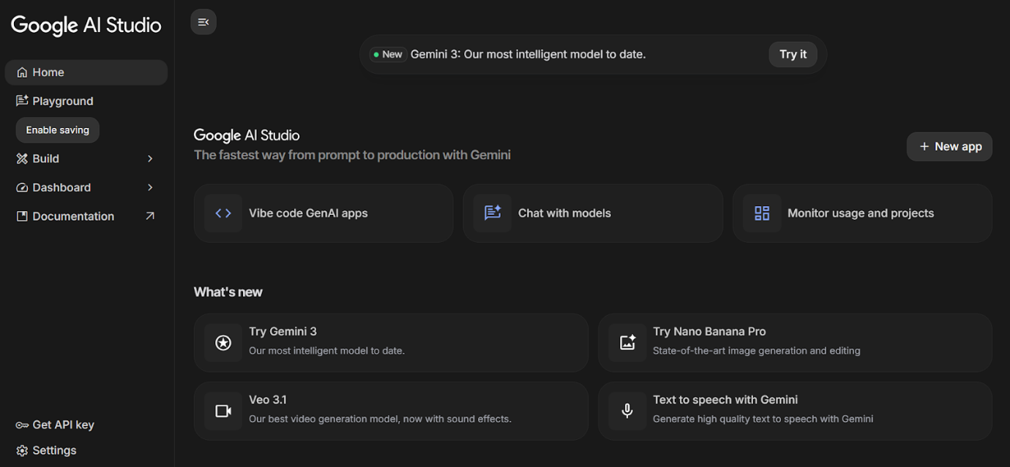
Activity 1.2: Configure environment and test connection
- Create .env file
Create a .env file in the project root directory to securely store API credentials.
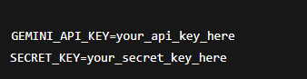
- Install dependencies
Install the Gemini SDK and environment management libraries.

Activity 2.1: Flask Initialization and Import Libraries
Import Required Libraries
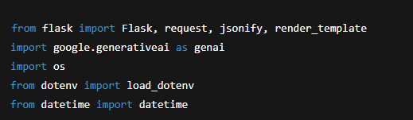
Flask Initialization
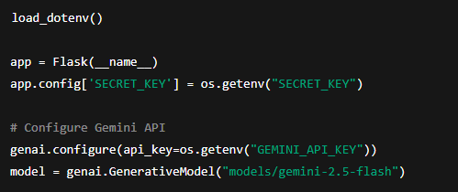
Activity 2.2: Main Functionality Code Routing
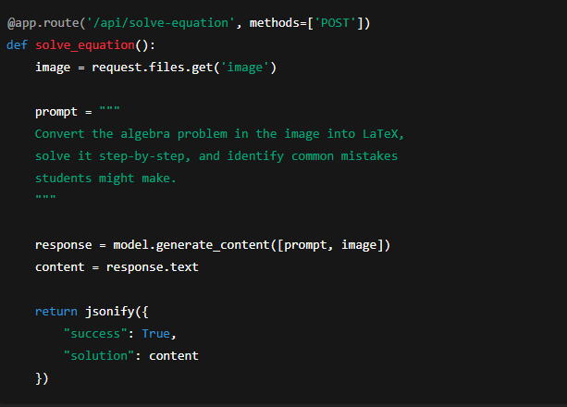
Question Bank Generation
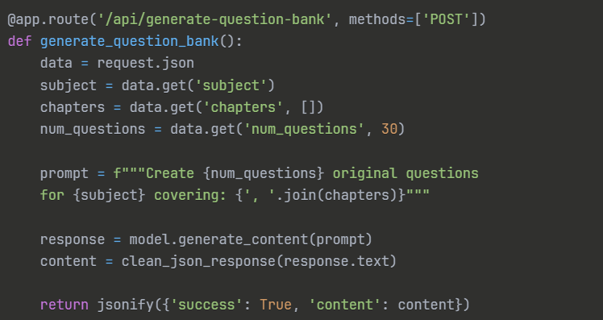
MILESTONE 3: Backend – Flask Integration (app.py)This
milestone focuses on implementing the complete Flask backend for the AI Math Tutor application. It integrates all previously developed AI modules, ensures secure API routing, handles errors gracefully, and supports export-ready outputs. The backend enables seamless communication between the user interface and the AI-powered math processing engine.
Activity 3.1: Complete Route Definitions
All backend routes are fully defined and validated to ensure reliable system behavior. Each API endpoint includes:
- Input validation for image and equation data
- Proper error handling and fallback responses
- Logging for debugging and monitoring
- Structured JSON response formatting
Defined API Routes
- /api/image-to-latex – Converts uploaded algebra problem images into LaTeX format
- /api/solve-equation – Generates step-by-step algebra solutions
- /api/mistake-check – Identifies common student mistakes and trap areas
- /api/export-pdf – Exports solutions as formatted PDF files
- /api/export-word – Exports solutions as Word documents
Activity 3.2: Modular Architecture
Main Application Structure
The Flask backend follows a modular architecture to improve maintainability, scalability, and debugging efficiency. Core logic is separated into independent utility modules.
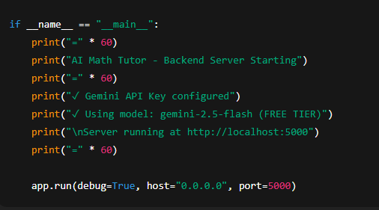
Backend Module Responsibilities
- ocr_utils.py – Image preprocessing and symbol recognition
- solver.py – Step-by-step algebra solving logic
- mistake_check.py – Detection of common algebra mistakes
- export_utils.py – PDF and Word file generation
- response_utils.py – JSON cleanup and formatting
This structure ensures clean separation of concerns and enables future expansion to support calculus or geometry.
Activity 3.3: Export Implementation
The AI Math Tutor supports professional-quality output formats for academic use.
- Export Features Implemented
- PDF generation with mathematical formatting and solution steps
MILESTONE 4: UI Development
This milestone focuses on designing and implementing an intuitive, responsive, and student-friendly frontend for the AI Math Tutor application using Streamlit, HTML, CSS, and basic JavaScript concepts (where applicable). The UI enables users to upload algebra problem images, view step-by-step solutions, and understand mistake-prone areas clearly.Activity 4.1: Home Page Development
Landing Page Features:
- Hero section with project description
- Feature cards for each generator
- Easy navigation
- Responsive design
Activity 4.1: Home Page Development
Landing Page Features
- Hero section with AI Math Tutor project overview
- Clear description of image-based algebra solving
- Feature cards highlighting core functionalities
- Simple and intuitive navigation
- Fully responsive design for desktop and mobile users
Home Page Feature Highlights
- Upload Algebra Image – Allows students to upload handwritten or printed algebra problems
- LaTeX Conversion – Displays converted mathematical expressions
- Step-by-Step Solution – Shows structured reasoning
- Mistake Detection – Highlights common algebra traps
Activity 4.2: Core Functional Pages
1. Algebra Problem Solver Page
UI Components:
- Image upload field (PNG/JPG)
- Preview of uploaded image
- Converted LaTeX equation display
- “Solve Problem” button
- Loading indicator during AI processing
Displayed Output:
- Recognized equation in LaTeX format
- Step-by-step solution cards
- Final numeric answer

2. Step-by-Step Solution Display
Features:
- Clearly numbered steps
- Mathematical formatting using LaTeX rendering
- Easy-to-read explanation text
- Section-wise separation of steps

MILESTONE 5: Testing & Optimization
This milestone focuses on validating the correctness, reliability, and performance of the AI Math Tutor system. Comprehensive testing is performed to ensure accurate algebra recognition, step-by-step problem solving, and effective mistake detection across different difficulty levels.
Activity 5.1: Comprehensive Testing
Test Scenarios
1. Algebra Problem Solver Testing
- Subject: Mathematics
- Topic: Algebra (Linear Equations)
- Difficulty: Medium
- Input Type: Image-based problems
- Expected Output:
  - Correct LaTeX equation extraction
  - Accurate step-by-step solution
  - Correct final numeric answer
Test Cases Include:
- Simple linear equations
- Multi-step algebraic equations
- Equations with fractions and negative values
- Handwritten and printed algebra images
3. Edge Case Testing
- Blurry or low-quality images
- Incomplete equations
- Non-algebra images
- Unsupported symbols
Expected Behavior:
- Graceful error handling
- User-friendly feedback messages
- No system crashes
Activity 5.2: Quality Evaluation
Evaluation Criteria
- Solution Accuracy: Correctness of final answer
- Step Clarity: Logical and easy-to-follow explanation
- LaTeX Accuracy: Proper mathematical formatting
- Mistake Identification: Relevance and clarity of detected errors
- User Readability: Student-friendly language
Result Analysis
- High accuracy for clean algebra images
- Clear step-by-step reasoning suitable for learners
- Effective identification of common algebra mistakes
- Consistent output formatting across different inputs

Conclusion
The AI Math Tutor project successfully demonstrates the practical application of Generative AI in the field of education by providing an intelligent, interactive, and student-friendly solution for solving algebraic problems. By leveraging image-based input and advanced AI reasoning, the system bridges the gap between traditional handwritten problem-solving and modern digital learning tools.
The application effectively converts algebra problem images into structured mathematical expressions using symbol mapping, solves equations with step-by-step explanations, and identifies common student mistakes with corrective guidance. This not only helps learners reach the correct answer but also strengthens their conceptual understanding of algebra.

